Together-While-Still Apartments Inc. (TWSA) manages the rental of furnished apartments and lofts using a database whose Logical Data Model is shown here. Answer the questions below based this model only (i.e. "Discover, Don't Invent") A yes/no answer is not sufficient. You must cite what specific part of the data model provides the answer. The connectivity symbols are labeled with letters to make it easy to give short, specific, complete answers. A letter (such as C or R) is sufficient to identify a minimum or maximum symbol in your answer. Do not “over-answer” – if H alone is the right answer, do not say “G and H” or “E,F,G,H” (both wrong).
Together-While-Still Apartments Inc. (TWSA) ERD:
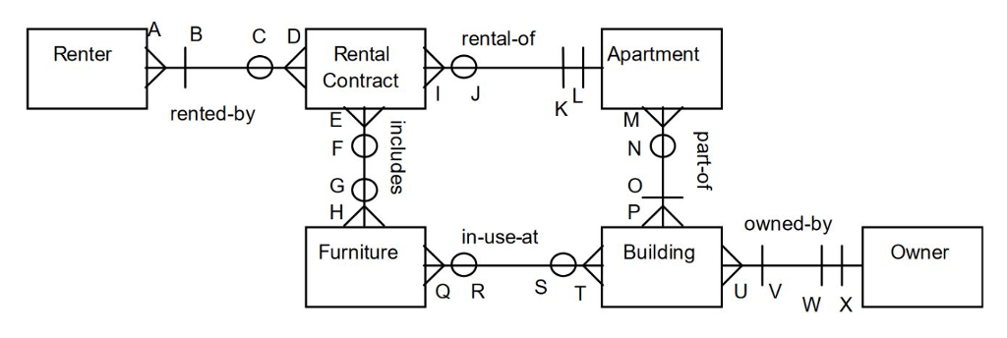
- Can new furniture be recorded as soon as it is purchased? How do you know?
New furniture can be added according to this database design. The relation (symbol F) between Furniture and Rental Contract shows that a furniture can has zero or more rental contact. The symbol S shows that a furniture can in use at zero or multiple buildings.
(b) What part of the model is redundant? How would you change the model to eliminate the redundancy? Why won't users lose information if you make this change?

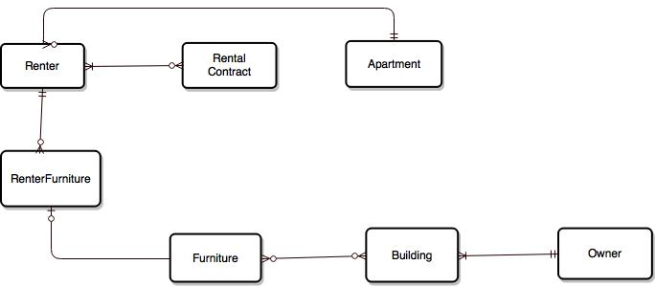
If a renter has signed more than one rental contracts but rent only one apartment so this data storage cause of redundancy. Relation D, and I are causes of redundancy. So I have created a separate relationship between renter and Apartment.
Relation E, H cause of redundancy. To remove this, I have created separate relation between Renter and Furniture. I have created a new entity “RenterFurniture”. A renter can rent zero or more renter furniture.
- Under what conditions will an apartment be deleted from the database? How do you know?
If owner of an apartment arranges another agency to manage apartment rental details, then TWSA agency will remove this apartment details from the database.
- Suggest 3 good potential identifiers (candidate keys) for the Rental Contract entity. (3 different alternatives, not one concatenation.)
- Primary key ( renterID, apartmentID) renterContractID will be unique
- Primary key ( renterID, renterContractID)
- Primary key ( renterID,furnitureID) renterContractID will be unique

- Can TWSA use this database to track prospective new renters or former renters who might rent from them again? How do you know?
yes, TWSA use this database to track new renters and old renter’s details. When details are stored into database, this will remain in database until this data is not deleted from the database according to requirement. So I can easily track needed information from the database according to our requirements. For example, if renter Id exits in the “RentalContract” it means this renter is former renter else, it is new renter.
(f) As the model is presented here, what information must always be available for any rental contract in the database? (3 things)
According to this model, registered renter personal details will always remain in the database. And these renters are called former renters. “RentalContract” entity has the renterid and rented appartementid. So by renterid we can access the renter personal details from the “Renter” entity table and by appartmentId we can access renter’s apartment details.
(g) The office manager has suggested adding a “used-by” relationship between Furniture and the Renter. What is your reply to this suggestion? Why?
First we have to remove the EFGH relation between “RentalContract” and “Furniture”. And then we can create used-by relation between “Renter” and “Furniture”.
(h) What happens if the person who is the owner of a building rents (leases for his or her own use) an apartment in that building? Explain the effect on the database.
Current database design will support this change. There will not be any effect on the database. The relation “J” shows that an apartment can has zero or more renters so it simply specifies that there may be number of apartments in “Apartment” table that need not to be rented.
(i) If 4 college students share a 2-bedroom apartment, how many rental contract instances will the roommates have to sign?
There will be four instances of rental contract. Each renter student has to registerd with the system so the Renter will have four instances for these four students. And each renter has to sign the contract for an apartment so four renterids with same contracte id and with same apartment id will be created in “RentalContract”. The A relation shows that A “RentalContract” can be signed by many renters. Same the relation I shows that an apartment can be rented by many rental contracts.
(j) One feature of this model will never be used because it exceeds a physical limitation of the real world. Identify the item and describe the physical limit.
The concept of furniture will be unused and wasted according to this database. Let’s assume we have fixed some furniture to a particular apartment or building and then a customer wants to rent an apartment and does not want to rent furniture for this reason. At that point it became tough to handle the database because according to this situation we have to shift this furniture to not rented apartment. And now this become a very difficult to maintain furniture for each apartment.

